Database Systems · Open-Ended Lab

CarGo Rentals
A relational database for a car rental company
Submitted by | Syeda Khadija Hassan
Roll number | 2024-SE-09
Department | Software Engineering
University | University of Azad Jammu & Kashmir, Muzaffarabad
Course | Database Systems (Lab)
Submitted to | Engr. Awais Rathore
Date | September 2026

Section 1

Introduction
CarGo Rentals hires out cars by the day or week, but keeps customers, vehicles, rentals, returns and payments in spreadsheets. As the business grows this causes duplicated data, inconsistent records and slow reporting. This project replaces the spreadsheets with a relational database that stores every fact once, calculates rental charges, tracks payments, and refuses to rent out a vehicle that is already rented. Management’s three reports (rental history, vehicles currently out, vehicle activity) are answered with JOIN queries and one view.
The work is delivered as three files: CarGo_Rentals.sql (database, tables, constraints, sample data, JOINs, view, triggers, stored procedures and the optimization test, runnable top to bottom), this report, and CarGo_Rentals_Outputs.docx (the recorded output of every query and test). Everything was executed on MariaDB 10.11; the syntax is MySQL-compatible.
Section 2

Database design and implementation (Task 1)

2.1 Entity-relationship diagram
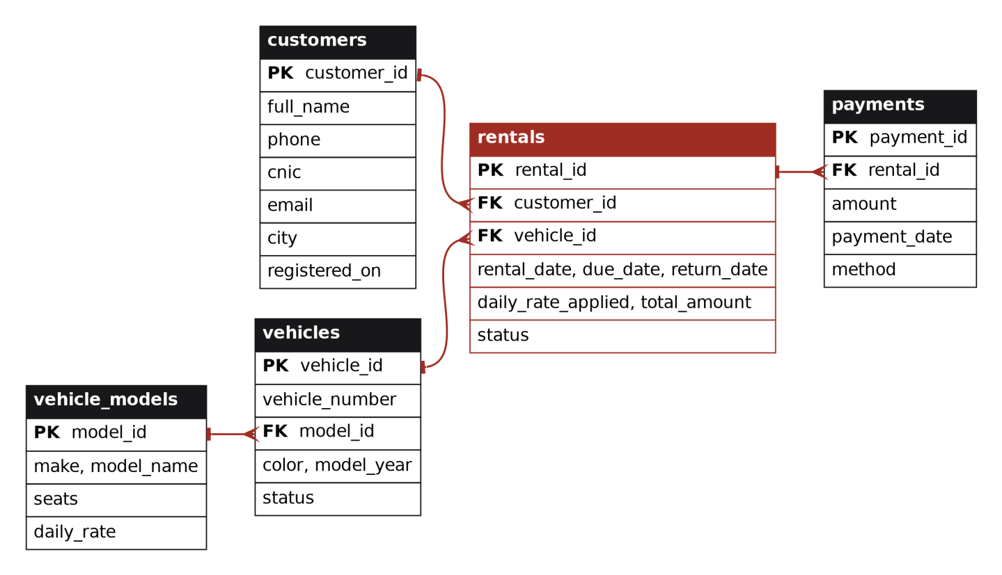
Figure 1 — Five tables. Each relationship is one-to-many; the crow’s foot marks the “many” side.

2.2 Tables, keys and relationships
Table | Purpose | Keys
customers | Who rents. | PK customer_id. UNIQUE: phone, cnic, email.
vehicle_models | Make/model catalogue; owns the daily rate. | PK model_id. UNIQUE (make, model_name).
vehicles | Each physical car, identified by its plate. | PK vehicle_id. UNIQUE vehicle_number. FK model_id → vehicle_models.
rentals | One row per rental: dates, agreed rate, charge, status. The return is recorded here too. | PK rental_id. FK customer_id → customers. FK vehicle_id → vehicles.
payments | Money received. One rental can have several payments (advance, balance). | PK payment_id. FK rental_id → rentals.

2.3 Constraints applied
Constraint | Where | Why
PRIMARY KEY, FOREIGN KEY | Every table. Foreign keys use ON DELETE RESTRICT. | No orphan rows; rental history can never be deleted by accident.
NOT NULL | Names, phone, CNIC, dates, rates, amounts, statuses. | Mandatory facts must be present.
UNIQUE | phone, cnic, email, vehicle_number, (make, model_name). | Stops duplicate customers and vehicles, the “duplicate information” problem in the scenario.
CHECK | Phone, CNIC and plate formats; daily_rate > 0; due_date > rental_date; return_date ≥ rental_date; amount > 0; allowed status values; Active ⇔ no return date. | Invalid data is rejected by the database itself, whichever application sends it.
DEFAULT | status (Available / Active), seats = 5, payment method = Cash, registered_on and payment_date = today. | Sensible values without extra typing.

2.4 Design decisions and justification
- The rate belongs to the model, not the car. Every Corolla costs the same, so daily_rate lives in vehicle_models. Changing a price is one update, not one per car (this is the 3NF step in Section 3).
- The price is frozen on the rental. rentals stores daily_rate_applied and total_amount. This is deliberate: if only a reference to the price list were kept, raising the Corolla rate next month would silently rewrite last month’s invoices. The stored values are the contract price at booking time, and a late return adjusts total_amount.
- Payments are a separate table. A customer may pay an advance and the balance later, so one rental has many payments. Amount paid and balance due are calculated (in the view), never stored, so they cannot drift out of step.
- A return is a column, not a table. A rental is returned at most once, so return_date and status in rentals are enough; a separate returns table would add a join for no benefit.
- vehicles.status is controlled redundancy. Availability could be worked out from the rentals table, but a stored status makes “which cars are free?” instant. To keep it correct, three triggers update it automatically (Section 4).
- Surrogate keys plus UNIQUE natural keys. Compact integer keys join fast and never change; phone, CNIC and plate number remain UNIQUE so real-world duplicates are still blocked.
- Realistic sample data (PKR): 10 customers, 8 models, 12 vehicles, 17 rentals and 18 payments. Rental 1 is the handout’s record R001. The data deliberately includes edge cases: two customers who never rented, five cars currently out, one in maintenance, one late return, and rentals that are fully paid, partly paid and unpaid.
Section 3

Normalization (Task 2)
The company stores each rental as one flat record. Below is the handout’s record R001, plus three invented rows (R002–R004) to show what happens as the table grows.
RentalID | Customer Name | Customer Phone | Vehicle Number | Vehicle Model | Daily Rate | Rental Date | Return Date | Payment Amount
R001 | Ali Khan | 0300-1234567 | ABC-123 | Toyota Corolla | 5000 | 2026-09-01 | 2026-09-04 | 15000
R002 | Ali Khan | 0300-1234567 | LEA-4521 | Toyota Corolla | 5000 | 2026-07-15 | 2026-07-22 | 35000
R003 | Fatima Noor | 0345-1122334 | ABC-123 | Toyota Corolla | 5000 | 2026-09-06 | 2026-09-10 | 20000
R004 | Ayesha Siddiqui | 0321-7654321 | ISB-786 | Honda Civic | 6500 | 2026-06-10 | 2026-06-13 | 19500
Table 1 — The flat record. Only R001 comes from the handout; R002–R004 are illustrative.

3.1 Assumptions: the dependencies in the data
- RentalID → every other attribute (each rental has one ID).
- CustomerPhone → CustomerName (a phone number identifies one customer).
- VehicleNumber → VehicleModel (a plate belongs to one car of one model).
- VehicleModel → DailyRate (rates are set per model in the price list).
- PaymentAmount = (ReturnDate − RentalDate) × DailyRate, so it is derived. For R001: 3 days × 5,000 = 15,000.
- (VehicleNumber, RentalDate) is a second candidate key, because a car can start only one rental per day.

3.2 What is wrong with the flat record
Redundancy. Ali Khan’s name and phone appear in R001 and R002; “Toyota Corolla, 5000” appears three times; ABC-123’s details appear in R001 and R003.
Update anomaly. Raising the Corolla rate to 5,500 means editing three rows. Miss one and the same model has two prices. Changing Ali’s phone number means two edits.
Insertion anomaly. A new car, a new customer or a new model cannot be recorded until a rental exists for it, because a row needs a RentalID and dates.
Deletion anomaly. Deleting R004, the only Civic rental, also erases the fact that ISB-786 exists, that it is a Honda Civic at 6,500 a day, and Ayesha’s contact details.
Derived-data inconsistency. PaymentAmount can disagree with dates × rate, and it mixes “what is owed” with “what was paid”.

3.3 First Normal Form (1NF)
Problem. VehicleModel holds two facts in one value (“Toyota Corolla” is a make and a model), so the data cannot be searched or grouped by make. The table also has no formally declared key.
Change. Split the value into VehicleMake and VehicleModel; declare RentalID as the primary key, with (VehicleNumber, RentalDate) as an alternate key. Every attribute now holds a single, atomic value.
Rental(RentalID, CustomerName, CustomerPhone, VehicleNumber, VehicleMake, VehicleModel, DailyRate, RentalDate, ReturnDate, PaymentAmount)
Resolved: non-atomic values. Still present: all the redundancy and anomalies listed above, because they come from dependencies between columns, not from atomicity. (If payments could be made in instalments, PaymentAmount would become a repeating group; that is removed at 3NF by giving each payment its own row.)

3.4 Second Normal Form (2NF)
Problem. VehicleNumber alone determines VehicleMake, VehicleModel and DailyRate. VehicleNumber is only part of the candidate key (VehicleNumber, RentalDate), so these are partial dependencies. That is why a car’s details are repeated on every rental of that car.
Change. Move the vehicle facts into their own relation.
Vehicle(VehicleNumber, VehicleMake, VehicleModel, DailyRate)
Rental(RentalID, VehicleNumber, CustomerName, CustomerPhone, RentalDate, ReturnDate, PaymentAmount)
Resolved: vehicle details are stored once per car, so updating a car is a single edit and a car can exist before its first rental (fixes the insertion and deletion anomalies for vehicles). Still present: customer and rate redundancy.

3.5 Third Normal Form (3NF)
Problem. Three transitive dependencies remain, where a non-key attribute determines another non-key attribute: (a) RentalID → CustomerPhone → CustomerName; (b) VehicleNumber → VehicleModel → DailyRate; (c) PaymentAmount is calculated from the dates and DailyRate, and mixes charge with payment.
Change. Give each fact its own relation and link them with foreign keys.
Customer(CustomerID, CustomerName, CustomerPhone)
VehicleModel(ModelID, VehicleMake, VehicleModel, DailyRate)
Vehicle(VehicleID, VehicleNumber, ModelID)
Rental(RentalID, CustomerID, VehicleID, RentalDate, ReturnDate)
Payment(PaymentID, RentalID, Amount, PaymentDate)
Underlined = primary key; red italic = foreign key.
Resolved: every fact is stored exactly once. A rate change is one row; customers, models and vehicles exist without any rental; a rental can have many payments; and the total is calculated rather than stored as an independent value. These five relations are the tables implemented in Section 2 (which adds constraints, status columns and the frozen-price snapshot explained in 2.4). R001 now looks like this:
Table | R001 as stored
Customer | (1, Ali Khan, 0300-1234567)
VehicleModel | (1, Toyota, Corolla, 5000)
Vehicle | (1, ABC-123, model 1)
Rental | (1, customer 1, vehicle 1, 2026-09-01, 2026-09-04)
Payment | (rental 1, 15000, 2026-09-04)

3.6 Summary and check
Stage | Problem found | Change made | Anomaly removed
1NF | “Toyota Corolla” is two facts in one value; no declared key. | Split make and model; declare the key. | Non-atomic data.
2NF | Vehicle facts depend on part of the key (VehicleNumber). | Separate Vehicle relation. | Vehicle redundancy; insert / delete anomalies for cars.
3NF | Transitive: Phone → Name, Model → Rate; derived payment. | Customer, VehicleModel, Payment relations. | Customer and rate redundancy; update anomaly; derived-value drift.

Lossless check. A query in the SQL file joins the normalized tables and reproduces the handout’s record R001 exactly (same customer, plate, model, rate, dates and payment), which shows the decomposition lost no information. Its output is in the Outputs document.
Section 4

View, triggers and stored procedure (Tasks 4 and 6)

4.1 View: vw_rental_report
The view joins customers, vehicles, models, rentals and payments into one consolidated report: customer and phone, plate and model, dates, days, daily rate, total charge, amount paid, balance due and a payment status of Paid, Partial or Unpaid. It is useful because staff and management read one ready-made report instead of rewriting a five-table join with a payment subtotal each time, and every report shows the same numbers. It can also be filtered directly, for example balance_due > 0 to chase unpaid rentals.

4.2 Triggers: the “not available while rented” rule
- trg_rentals_bi (BEFORE INSERT) rejects a booking if the vehicle is rented or in maintenance, or if its dates overlap another rental of the same car.
- trg_rentals_ai (AFTER INSERT) sets the vehicle’s status to Rented when a new active rental is created.
- trg_rentals_au (AFTER UPDATE) sets it back to Available when a rental changes from Active to Returned.
Because the rule sits in the database, it holds no matter which program or person inserts the data.

4.3 Stored procedures
sp_register_rental(customer, plate, start date, days, advance, method → rental id, total) is the required procedure. It validates the inputs, locks the vehicle row so two clerks cannot book the same car, reads the model’s daily rate, calculates the charge (rate × days), inserts the rental with its due date, records the optional advance payment, and commits. Any error rolls everything back. sp_return_vehicle (a bonus) closes a rental and recalculates the charge if the car came back late; the trigger then frees the vehicle.
Testing. Fourteen invalid actions were tried and all were rejected with a clear message: six constraint violations, three trigger violations and five invalid procedure calls. A full life-cycle was also run: register a rental (12,000 charge, vehicle becomes Rented), then return it two days late (charge becomes 18,000, vehicle becomes Available).
Section 5

Optimization analysis (Task 7)

5.1 The problem
Management’s monthly activity report needs the rentals of one month. The natural way to write it is:
SELECT vehicle_id, COUNT(*) AS rentals, SUM(total_amount) AS revenue
FROM rentals
WHERE YEAR(rental_date) = 2026 AND MONTH(rental_date) = 8
GROUP BY vehicle_id;
This has two weaknesses. There is no index on rental_date, and the condition wraps the column in the functions YEAR() and MONTH(). A predicate written this way is not “SARGable”: the database has to compute the functions for every row, so even an index on rental_date cannot be used.

5.2 Why it matters
With 17 rows nobody notices. But a rental company adds rows every day, and every monthly report would read the entire history: the cost grows with the size of the table, not with the size of the month asked for. The same query returns identical results either way, so this is purely a performance problem, not a consistency one.

5.3 The improvement
Add an index on rental_date and rewrite the condition as a plain date range, which the index can search directly:
CREATE INDEX idx_rentals_rental_date ON rentals (rental_date);

SELECT vehicle_id, COUNT(*) AS rentals, SUM(total_amount) AS revenue
FROM rentals
WHERE rental_date >= '2026-08-01' AND rental_date < '2026-09-01'
GROUP BY vehicle_id;

5.4 Evidence
To measure the effect honestly, a 100,000-row copy of the rentals table (two years of history) was generated inside the SQL file. The table shows what the optimizer’s EXPLAIN reports and the median run time over 40 executions.
Variant | Index on rental_date | Access method | Rows read | Time | Key used
A. Original: YEAR() / MONTH() | No | Full scan of all rows | 100,000 | 79 ms | None useful
B. Same query, index added | Yes | Full scan (index ignored) | 99,750 | 77 ms | None useful
C. Date range + index | Yes | Range scan | 4,247 | 4.3 ms | idx_perf_rental_date
Table 2 — Measured on MariaDB 10.11, 100,000 rows. “Rows read” is the optimizer’s estimate from EXPLAIN. Exact milliseconds vary by machine; the row counts and the ratio are the evidence.
Variant C reads about 4% of the table and is roughly 19 times faster. Variant B is the key lesson: adding the index alone changes nothing, because the function on the column stops it being used. Both the index and the rewrite are needed. The two versions were checked to return identical results.

5.5 Trade-offs and next step
An index costs some disk space and makes each insert slightly slower, because the index must be updated too. That is a good trade for a table that is written once per rental but read by many reports. The improvement has been applied to the real database (idx_rentals_rental_date). A further step, if reports grew heavier, would be a composite index on (rental_date, vehicle_id, total_amount), which lets this query be answered from the index alone. The general rule to keep: never wrap an indexed column in a function inside WHERE; move the arithmetic to the other side.
Section 6

Conclusion
The database stores each fact once, enforces its business rules with keys, constraints and triggers, calculates charges in a stored procedure, and answers management’s questions through JOINs and a view. Normalization to 3NF removed the redundancy and the update, insertion and deletion anomalies of the spreadsheet record, and the optimization analysis showed a measured 18-fold improvement for the monthly report.

